Sorry the project is incomplete because in my hive date datatype is not being accepted as it throws null values.

I tried to use python udf to convert datatype from string to date but python file is also not running in hive.

This is the reason I can’t create partitioned table.

When the cloud platform of all softwares is up on ineuron dashboard then I will complete this project.

create table Parking_Violations_Issued

(Summons_Number bigint,Plate_ID string,Registration_State string,Plate_Type string,Issue_Date string,Violation_Code int,Vehicle_Body_Type string,Vehicle_Make string,Issuing_Agency string,Street_Code1 int,Street_Code2 int,Street_Code3 int,Vehicle_Expiration_Date string,Violation_Location int,Violation_Precinct int,Issuer_Precinct int,Issuer_Code int,Issuer_Command string,Issuer_Squad string,Violation_Time string,Time_First_Observed string,Violation_County string,Violation_In_Front_Of_Or_Opposite string,House_Number string,Street_Name string,Intersecting_Street string,Date_First_Observed int,Law_Section int,Sub_Division string,Violation_Legal_Code string,Days_Parking_In_Effect string,From_Hours_In_Effect string,To_Hours_In_Effect string,Vehicle_Color string,Unregistered_Vehicle int,Vehicle_Year string,Meter_Number string,Feet_From_Curb int,Violation_Post_Code string,Violation_Description string,No_Standing_or_Stopping_Violation string,Hydrant_Violation string,Double_Parking_Violation string)

row format delimited

fields terminated by ','

tblproperties ("skip.header.line.count"="1");

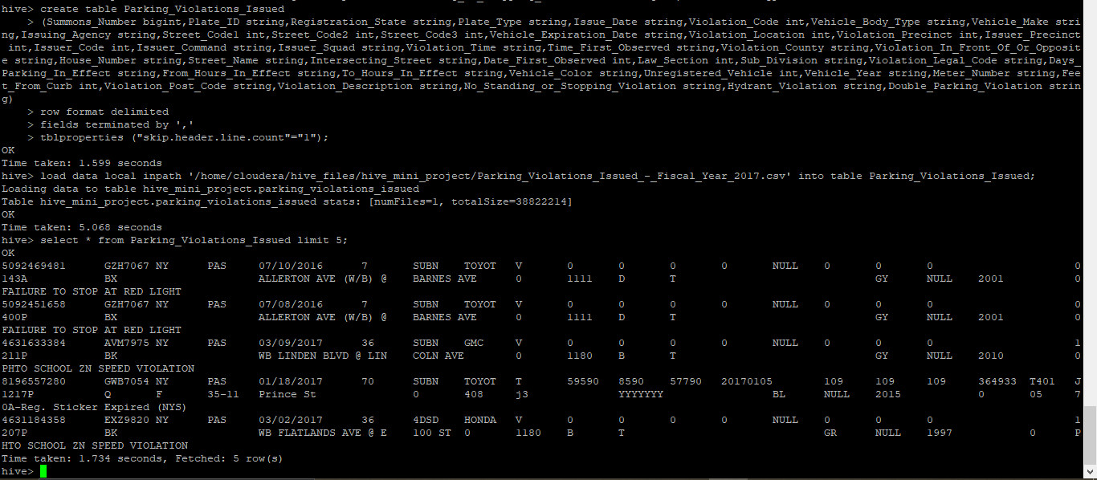

create table Parking_Violations_Issued_2017

(Summons_Number bigint,Plate_ID string,Registration_State string,Plate_Type string,Issue_Date string,Violation_Code int,Vehicle_Body_Type string,Vehicle_Make string,Issuing_Agency string,Street_Code1 int,Street_Code2 int,Street_Code3 int,Vehicle_Expiration_Date string,Violation_Location int,Violation_Precinct int,Issuer_Precinct int,Issuer_Code int,Issuer_Command string,Issuer_Squad string,Violation_Time string,Time_First_Observed string,Violation_In_Front_Of_Or_Opposite string,House_Number string,Street_Name string,Intersecting_Street string,Date_First_Observed int,Law_Section int,Sub_Division string,Violation_Legal_Code string,Days_Parking_In_Effect string,From_Hours_In_Effect string,To_Hours_In_Effect string,Vehicle_Color string,Unregistered_Vehicle int,Vehicle_Year string,Meter_Number string,Feet_From_Curb int,Violation_Post_Code string,Violation_Description string,No_Standing_or_Stopping_Violation string,Hydrant_Violation string,Double_Parking_Violation string)

partitioned by (Violation_County string)

clustered by (Violation_Code)

sorted by (Violation_Code) into 8 buckets;

insert into Parking_Violations_Issued_2017 partition(Violation_County) select Summons_Number,Plate_ID,Registration_State,Plate_Type,Issue_Date,Violation_Code,Vehicle_Body_Type,Vehicle_Make,Issuing_Agency,Street_Code1,Street_Code2,Street_Code3,Vehicle_Expiration_Date,Violation_Location,Violation_Precinct,Issuer_Precinct,Issuer_Code,Issuer_Command,Issuer_Squad,Violation_Time,Time_First_Observed,Violation_In_Front_Of_Or_Opposite,House_Number,Street_Name,Intersecting_Street,Date_First_Observed,Law_Section,Sub_Division,Violation_Legal_Code,Days_Parking_In_Effect,From_Hours_In_Effect,To_Hours_In_Effect,Vehicle_Color,Unregistered_Vehicle,Vehicle_Year,Meter_Number,Feet_From_Curb,Violation_Post_Code,Violation_Description,No_Standing_or_Stopping_Violation,Hydrant_Violation,Double_Parking_Violation,Violation_County from Parking_Violations_Issued where (Issue_Date)= '2017';